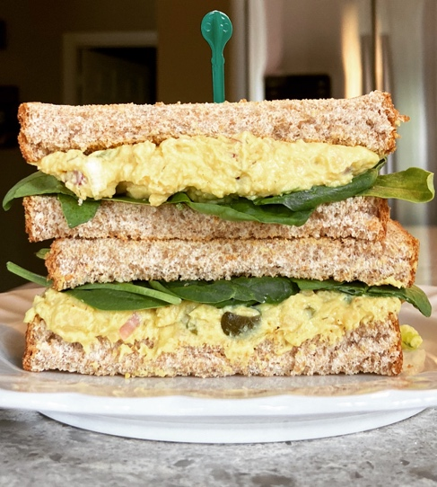
Chickpea salad Sandwich
Servings | Prep Time | Total Time
3-4 | 10 mins | ~10 mins

Ingredients
- 1 can of chickpeas, drained and rinsed
- 3 tbsp red onion
- 2 tbsp chopped dill pickles
- ¼ cup low-fat mayonnaise
- ¹/₃ cup plain low-fat Greek yogurt
  - Adjust depending on level of desired “creaminess”
- 2 tbsp Dijon mustard
- ½ tsp garlic powder
- ½ tsp onion powder
- ½ tsp turmeric
- ½ tsp dried dill (can also substitute for fresh dill)
- Paprika for taste
- Cayenne pepper for heat (optional)
- ½ tbsp lemon juice for taste (can add more acid if desired)
- Salt and pepper

For sandwich:
- 2 slices of whole grain bread
- Baby spinach and any other garnishes (ie. tomatoes)

Directions
- Drain chickpeas and rinse using a strainer. You can choose to remove the skins or keep them on. Removing skins will take ~5-10 minutes but will allow for a much more cohesive mixture.
- Put chickpeas in a big bowl and mash well using a potato masher or fork. Add rest of the ingredients and combine. Season to taste.
- Apply mixture to pieces of bread, add garnish and enjoy in sandwich form! You can also use this as a dip for veggies and crackers.

Note: This can be an alternate “egg-salad” sandwich for vegans: just substitute the yogurt and mayonnaise for vegan options!

